Bookbinding Styles
Updated July 27, 2020

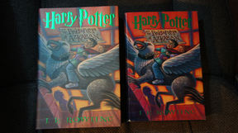
AS ISSUED: Generally used to clarify that some component of a book which is present or might appear to be missing is the state in which the book was originally published.

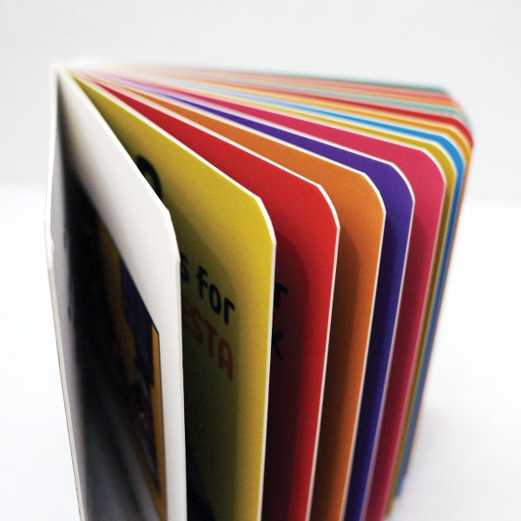
BOARD BOOK: A book for very small children, with the pages pasted to heavy cardboard.

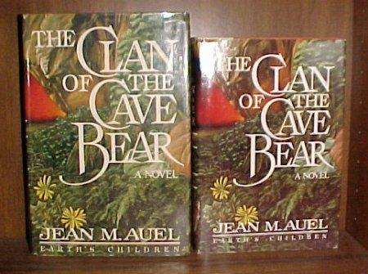
BOOK CLUB EDITIONS: Books printed solely for a book club to be sold to subscribers. While it is generally true that such books are smaller, have poorer quality bindings & often less expensive paper than the books issued by the publisher for the general retail market, there are exceptions among smaller clubs who specialize in reprinting new editions of books marketed as "collectible" or with appeal to a limited audience. Some major clubs blind stamp their back cover with their logo, print the club name on the front flap of the dustjacket, or are marked in other ways; others are identified by their dustjackets lacking a price on an inner flap lacking a price on the front flap or, in the case of more recent books, a bar code. Unmarked book club editions, or those lacking dustjackets, can be mistaken for first edition both because they were printed from the first edition plates and are explicitly so marked, or bear the identifying characteristics of the publisher's first editions.

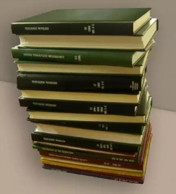
CLASS A LIBRARY BOOK: The traditional “Class A” library book incorporates double fan leaf attachment, rounding units over ½” thick, trimmed edges, and up to 5 lines of lettering on F grade buckram covers. Buckram is a stiff cloth used to cover and protect books. Modern buckrams have been stiffened by soaking in a substance, usually now pyroxylin, to fill the gaps between the fibers. This type of book often has a call letter on the spine.

COMB BINDING: A book bound by a tubular plastic into which a series of teeth have been cut. The teeth fit through small rectangular holes punched through the left edges of the covers & leaves of the book.
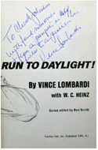
DEDICATION COPY: A copy of a book which has been inscribed in the author's hand as dedicated to the person he/she names.

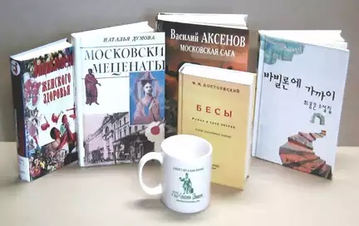
A COLOR 4 EVER (or 4-color) BOOK uses the same library binding methods as a Class A binding, but rather than a stamped buckram cover, the original cover artwork is reproduced on the cover.

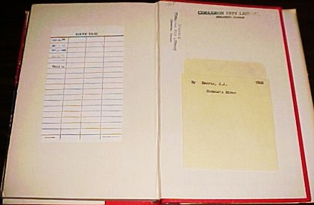
EX-LIBRARY/EX-LIB: A book which has signs that it was once owned by a public library or a private institution. The signs range from minimal, unobtrusive marks or stamps to a book laden with stampings, card pockets, catalog numbers on the spine, etc. While most libraries stamp books they have discarded to indicate that the book was not stolen nor lent & never returned, the practice is not universal. One should check with the library if a book lacking a discard stamp appears to be of unusual value. Some ex-library books may have been rebound in Buckram, a coarse linen which is heavier & more durable than the cloth used by publishers. The term itself does not imply anything about the condition of a book which may be quite decent. Ex-lib books, unless rare & important, are not collectible. Some out-of-print academic & scientific books, however, command high prices because their limited supply far exceeds the demand.
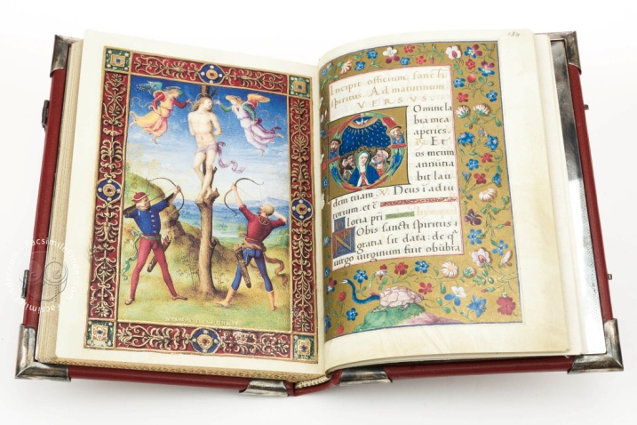
FACSIMILE: A reproduction of a book which attempts to capture the appearance of the printing in the original in all respects. Facsimiles are often marked as such and, unlike attempts to create a fraudulent copy of a book, make no attempt to deceptively emulate all the signs of an old book such as using old paper replete with the expected defects from use. The term also refers to any photo illustration included in a book which has been taken from the original document, letter, etc.; or to any part of an original book which has been replaced with a reproduction.
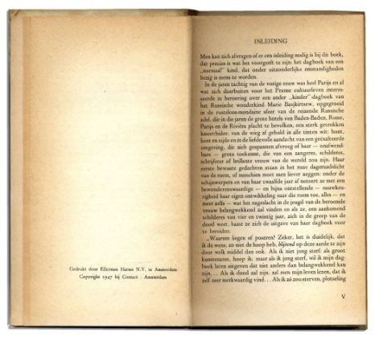
FIRST EDITION: The book will have no other copyright dates.
See “The Beginner’s Guide to Identifying First Editions, Part One” by Amanda Nelson (attached) for more information

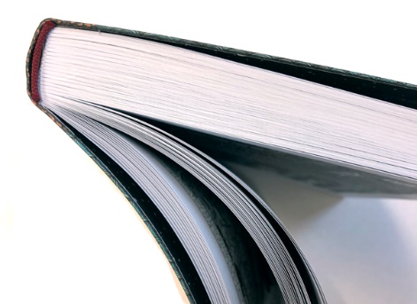
FLEXI-BOUND: Flexi binding is a popular binding style which sits between a paperback binding and a hardback binding. The case or cover is generally made with paperback cover stock which is folded over and separate ends applied.

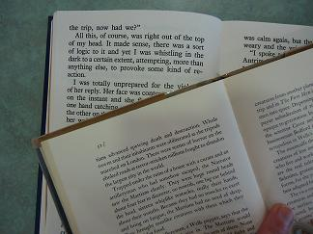
LARGE PRINT: Large-print (also large-type or large-font) refers to the formatting of a book or other text document in which the typeface (or font), and sometimes the medium, are considerably larger than usual, to accommodate people who have poor vision.

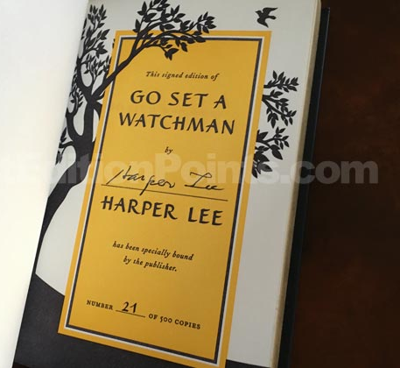
LIMITED EDITION: A book whose publication is, in whole or part, deliberately restricted to a comparatively small number of copies. Some limited editions are the only editions or printings of the book while others are a special edition released prior to the less artful copies of the book intended for the general retail market. True limited editions should give at least the total number printed, are usually numbered (e.g. "Number 552 of 1,000"), and may be signed by the author and/or illustrator. Limited editions are not necessarily valuable; and the so-called limited editions, which some unscrupulous publishers produce in large numbers or in whatever quantity can be sold, are rarely of any value. A true limited edition book which is not numbered (despite having an obvious place for the number to be written or stamped) is called Out Of Series. These are extra copies printed to replace defective or lost copies prior to their release, and are considered of less value by collectors being, as it were, the understudies of the limit edition.
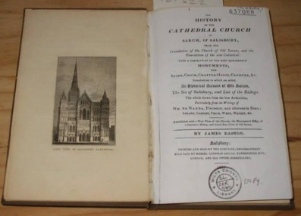
MADE-UP COPY: A copy of a book whose parts have been assembled from one or more defective copies.

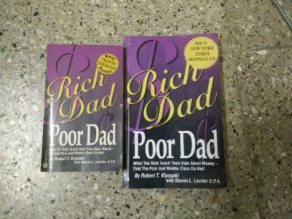
MASS MARKET PAPERBACK BOOK: Paperbacks, in general, are those books that are bound with glue-on paper covers, rather than cloth and board covers. The mass-market paperback is typically no larger than 5 x 8 inches (usually 4” by 6.5”) with varied depths. They are made with cheaper paper and are produced in large quantities, which is why they can have a low list price. A title published as a mass-market paperback often has high sales in hardcover and so is “mass” published in the small format. Romance, westerns, and best sellers are common genres for this bookbinding style. Mass-market was the original paperback size; sold in specially-sized racks at spots like drugstores and markets.
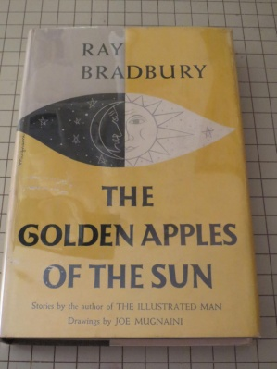
MYLAR COVERED HARDBOUND: Mylar sleeve has a white edge and is folded over to the inside.

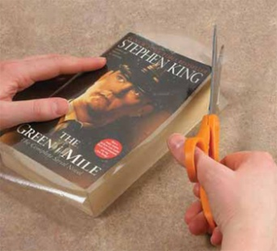
MYLAR COATED PAPERBACK: A paperback with film attached to the cover.

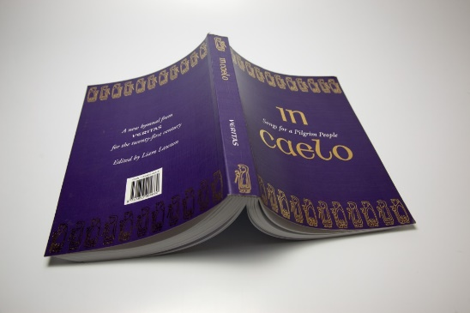
PERFECT PAPERBACK: A “Perfect” paperback is a binding term that refers to how the paperback cover is attached to the page block, and also how the pages are attached to each other. A “perfect bound paperback” has pages that are glued as a block to the cover. Contrast this to a hardcover book where the pages are sewn in signatures before being bound inside the cloth covered boards and endpapers applied. In this case “perfect” is not a condition term.
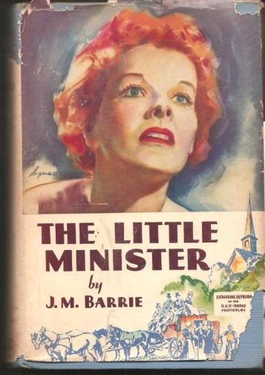
PHOTOPLAY EDITION: A book illustrated with still photographs of scenes from a motion picture based on the book, or a book based on the motion picture's script. The former, which is most often the case, is not a first edition. Photoplay editions can be more valuable than first editions if the movie has inspired more interest than the book upon which it was based. When this is not true, even as a later edition they have greater value than other later editions of the book because they are collected in their own right, valued by collectors of the actors or others responsible for the film, or collectors of the author or things pertaining to the film itself. Photoplay editions soared in popularity during the 1920s and declined rather rapidly thereafter.

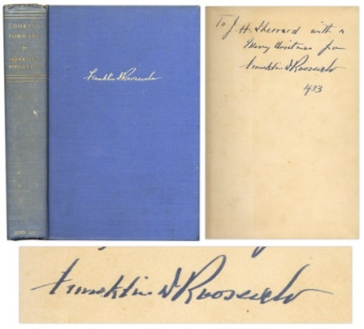
PRESENTATION COPY: A copy of a book which, either through self-evidence or by way of its Provenance, can be authenticated as one someone was given by the author. An author's inscription is the most common self-evidence.

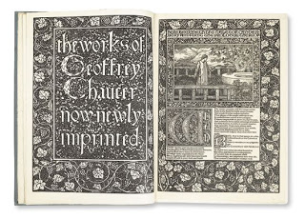
PRIVATE PRESS: An expression which once had a fairly clear reference to a small printer/publisher, or lone craftsperson, who eschewed the commercial book market in favor of producing small quantities of finely printed, special-interest, or otherwise limited market books. Today, the term has become so stretched as a marketing image that caution & research are advisable to determine which, if any, of the original characteristics a publisher may possess. There have been, however, many private presses over the years which deserve the reputation & respect the term once implied, so there are pleasant rewards for those willing to expend a little extra effort.
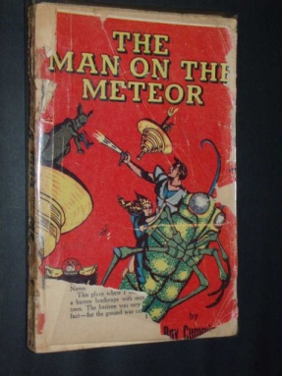
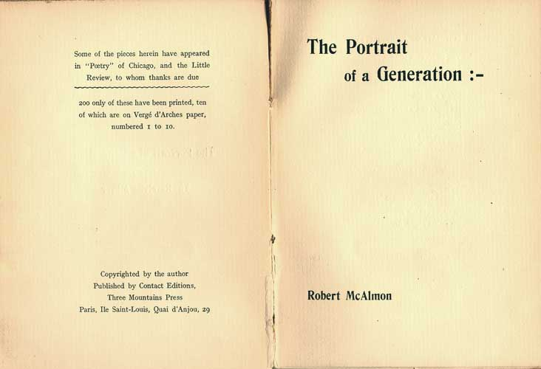
Privately Printed/ Self-Published: A book printed at the expense of an individual or a group which was usually intended either for private circulation rather than public sale, or for sale to a limited market of interested persons through means other than commercial book market. Occasionally, some privately printed books are bought by book distributors from the author, but typically it is the person or the group who market & distribute such publication. Thus, the essential characteristic of a privately printed book is that the publisher is the author.
READING COPY: A copy of a book in Fair to Poor condition you would buy only for the purpose of reading or using as a reference due to it undesirable condition. If the book was in better condition, collectible, and worth the investment, such a book might be a candidate for rebinding. Generally, however, such a book is a sad case of heavy wear, use & abuse which has the single virtue of possessing at least all of its text pages.

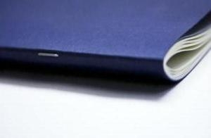
SADDLE STITCHING: Saddle Stitching refers to a very popular book binding method in which folded sheets are gathered together one inside the other and then stapled through the fold line with wire staples. The staples pass through the folded crease from the outside and are clinched between the centermost pages. Two staples are commonly used but larger books may require more staples along the spine.

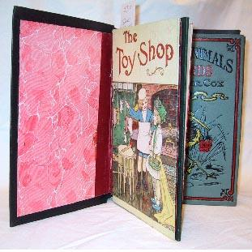
SALESMAN SAMPLE: A sample book designed by the publisher for use by door-to-door salespeople. These abbreviated books attempted to capture the most appealing features of a book and included at least the title page, several text pages, and some of the illustrations (if any). If the book was available in a choice of bindings, samples were often included in the book. Many also included a few pages in the back designed as a sales record for the salesperson. Books which were "Sold by Subscription only" were also marketed in this way by smaller publishers who attempted to print no more books than those necessary to fill a known demand.
TRADE EDITION: Used to distinguish an edition of a book published for the general retail market from a Limited Edition of the same book.

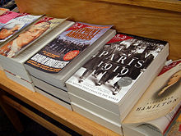
TRADE PAPERBACK BOOK: Paperbacks, in general, are those books that are bound with glue-on paper covers, rather than cloth and board covers. A ‘trade paperback’ can be many sizes, with the most common being 6 by 9 inches in the United States. They are printed on better paper and cost more than mass-market paperbacks. Many non-fiction books are published as trade paperbacks.

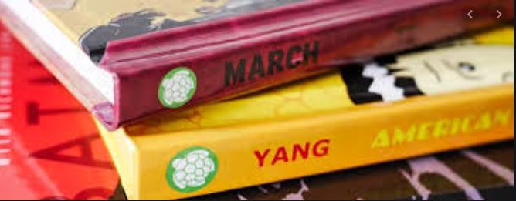
TURTLEBACK BOOK: A Turtleback is a hardcover version of a paperback, usually produced for the school or library market, produced by a company called Turtleback and which you can find online at their website. The book will look exactly like the paperback, with pictorial covers and reinforced hinges.
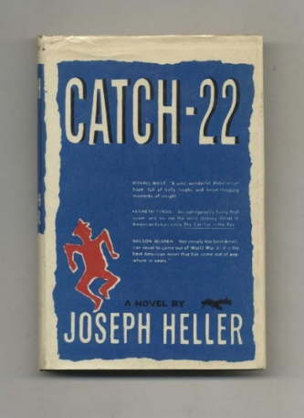
UNAUTHORIZED EDITION/Pirated Edition: An edition of a title published without the sanction of whoever holds the legal rights to the work, i. e. the author, the author's legal representative, the copyright holder, or the original publisher. Because issuing an unauthorized edition within the country in which it was originally published would be an infringement on those legal rights protected by that country's copy write laws, such "pirated" editions usually originate in a foreign country.

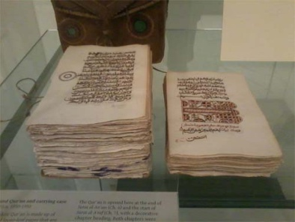
UNBOUND: Describes a book which has never been bound, but exists in one or another pre-bound state such as in its sheets, gatherings, or signatures. Proper use of the term implies that all sheets, gatherings or signatures necessary for a complete copy of the book are present. An unbound book is one who has yet to marry a cover while a disbound book is one who has divorced its cover.

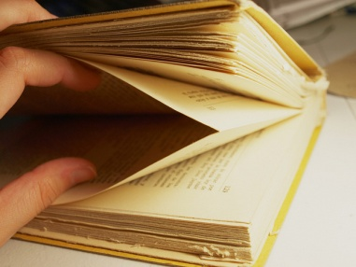
UNOPENED: A book whose leaves are still attached to the other leaves in its Signatures because the folds of its signatures have never been cut open. The leaves so affected cannot be opened to read the pages without cutting the folds with a knife. A book can have some or all of its leaves unopened. Not to be confused with Uncut.

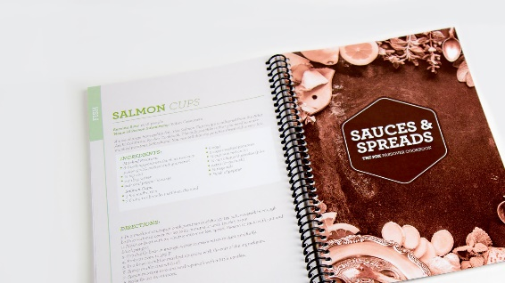
WIRE BOUND: A book bound by a helix-shaped wire, each coil of which penetrates a small hole punched through the left edge of the covers & the leaves of the book.

