
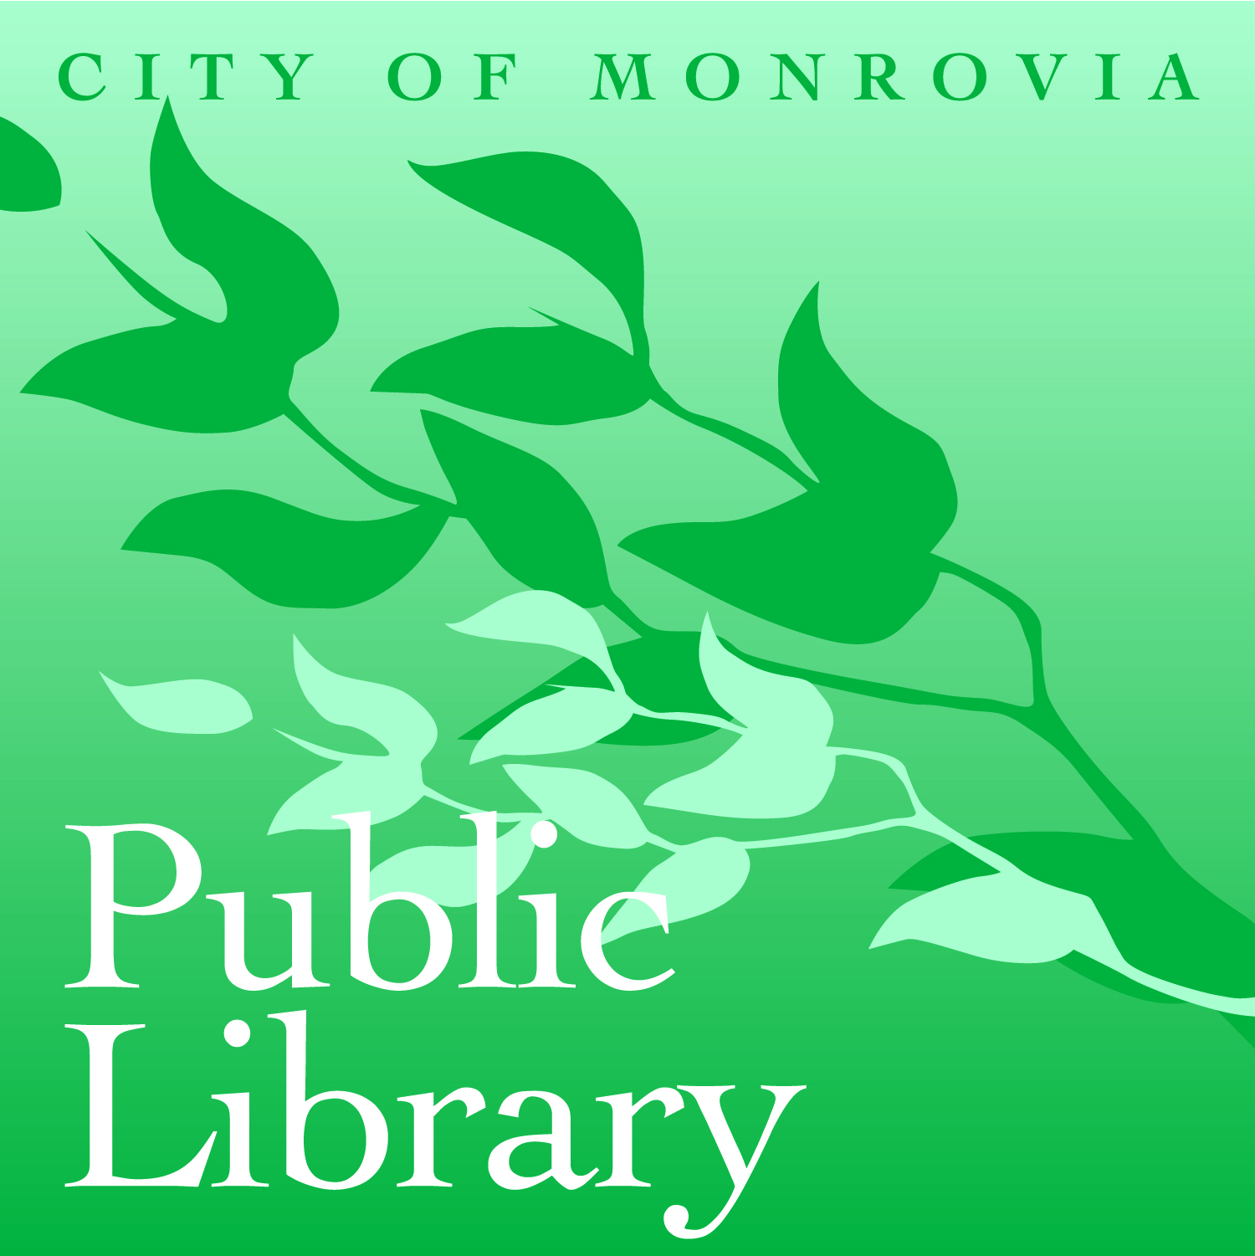
City of Monrovia, Department of Community Services
Monrovia Public Library

Library Orientation and Support Technician (LOST) Volunteer Job Description

Importance of Position
The library provides many services to enrich the community ranging from book check-out on virtually any subject to music CDs to computer use to programs that encourage and promote life-long learning. Libraries can be very intimidating, even to those who use libraries regularly. Volunteer greeters will be the first face of the new library, welcoming and orienting user to the building, thereby encouraging people to visit regularly and getting patrons familiar with the many services that the library offers. In essence, LOST volunteers will make sure that people aren’t lost at the library!

Qualifications
LOST volunteers must feel comfortable working with the public and giving very basic explanations of the library to the public. Familiarity with the Monrovia Public Library is helpful but not necessary. Good mobility is helpful to walk patrons to the destinations, but not necessary.

Responsibilities
- Commit to at least 5 hours a month volunteering as a LOST volunteer.
- Learn where the general sections of the library are and where programs are held. Training will be provided by library staff.
- Greet patrons as they come into the building.
- Ask if they need help finding specific resources or if they would like a general tour of the building. Direct or escort patrons to library staff that will provide the needed service.
- Promote programs and activities. Volunteers and staff will decide which programs to promote.
- Assist patrons with use of self check-out machines. Staff will train volunteers on how to do this.

Responsible to
Literacy Coordinator at the Monrovia Library: 626-256-8272 or literacyservices@ci.monrovia.ca.us.

Training Provided
Orientation and training will be provided by library staff. On-going meetings for volunteers and an on-line community will also be provided to answer questions about volunteering and promote communication among volunteers.

Benefits of Volunteering
By making the library a welcoming place, you are providing your community with all of the resources that the library has to offer, empowering them to learn new skills and knowledge. Other benefits of volunteering include training, letters of recommendation, and networking opportunities.

Time Commitment
LOST volunteers need to commit to five hours a month volunteering, which can be scheduled more or less at your convenience. Volunteers are welcome to work more than five hours a month.

Length of Commitment
The Library requires at least a six-month commitment to volunteering. Because there may not be a need for LOST volunteers on a long-term basis, volunteers may change to another volunteer position in the Library or elsewhere in the City.

Grounds of Termination
- Inability to attend or to fulfill weekly responsibilities, or for behavior unbecoming of the library. We expect our volunteers to be a good reflection of our services.
- Breach of confidentiality. Please do not discuss your patrons’ questions with anyone who knows them or in a way that might expose their identity.
- Failure to complete City background and drug test.

