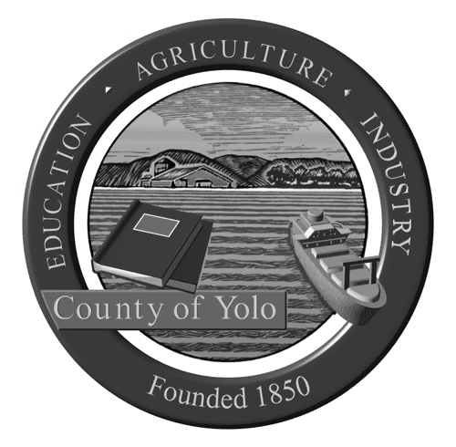

Yolo County Library
Tutor Incarcerated Youth

Youth who can read and write well have a greater chance of staying out of trouble when they are released from juvenile detention.

Our goal is to provide incarcerated youth with additional opportunities to improve their academic skills and discover the world of pleasure reading.

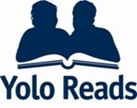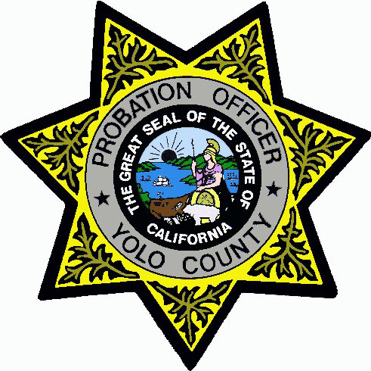

Yolo Reads @JDF is a program of the Yolo County Library
in partnership with the Yolo County Probation Department.

Volunteers visit the Juvenile Detention Facility in Woodland Tuesday evening for approximately 2 hours to tutor and mentor youth in the areas of reading, writing, social studies, science, and math. Tutoring is provided in English and in Spanish. Tutors provide one-on-one assistance and facilitate small groups.

Services are provided at the Juvenile Detention Facility at 2880 East Gibson Road in Woodland.
Qualifications:
- Required: Must be 21 years of age or older; pass background check; be flexible and patient.

- Preferred: Experience working with at-risk youth and/or teenagers; ability to tutor in math and science. Bilingual (Spanish) tutors needed!!!

Training and materials are provided.

For additional information, please contact Elizabeth Gray
at elizabeth.gray@yolocounty.org or 530-666-8005.

