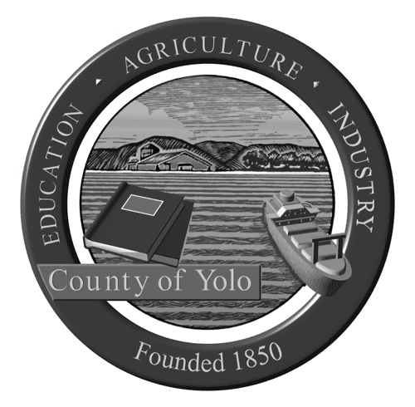

Yolo County Library
Volunteer Position Description

Title: Literacy Tutor, Juvenile Detention Facility

Position Overview and Impact: The Yolo County Library and Yolo County Probation Department are partnering to provide literacy services to youth incarcerated at the Juvenile Detention Facility in Woodland. Our goal is to provide youth with additional opportunities to improve their academic skills and discover the world of pleasure reading. A small group of volunteers will visit the Juvenile Detention Facility once a week to provide tutoring and mentoring to incarcerated youth in the areas of reading, writing, science, history, and math in English and Spanish.

Key Responsibilities:
- Meet weekly with a youth, or a small group of youths, to provide tutoring
- Work with a youth to identify his/her reading and writing goals engage the youth in tutoring sessions based on those interests and goals
- Complete short monthly reports
- Attend volunteer trainings and meetings.

Qualifications:
Required: Must be 21 years of age or older; pass background check; flexible and patient.
Preferred: Bilingual (Spanish) tutors needed; Experience working with at-risk youth and/or teenagers; experience with law enforcement or in an institutional setting; teaching experience.

Training and Support Provided: An orientation and introduction to work in the Juvenile Detention Facility are provided. Tutoring materials are also provided.

Time Commitment: 2-3 hours every Tuesday at the Juvenile Detention Facility at 2880 East Gibson Road in Woodland. A minimum 6-month commitment is required.

Benefits of Volunteering: Help the library provide valuable literacy services to incarcerated youth. Assist a young adult to improve his or her reading, writing or math skills.

Contact Person(s): Heather Bratt, Librarian, Adult Literacy, heather.bratt@yolocounty.org

Selection Process: Interested individuals should complete and submit a volunteer application. Applicants will be interviewed and will participate in a background check.

