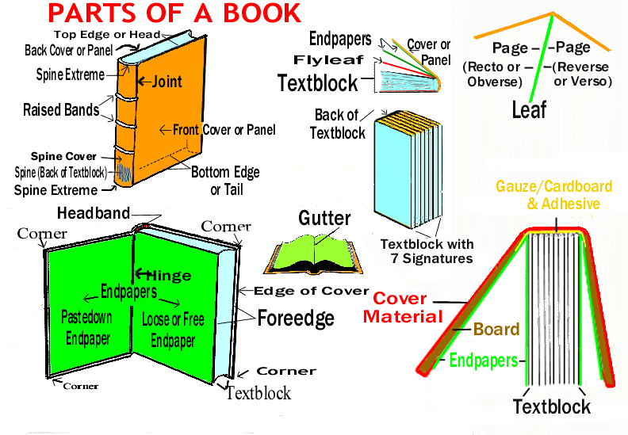
PARTS OF A BOOK
GLOSSARY
Updated November 4, 2021
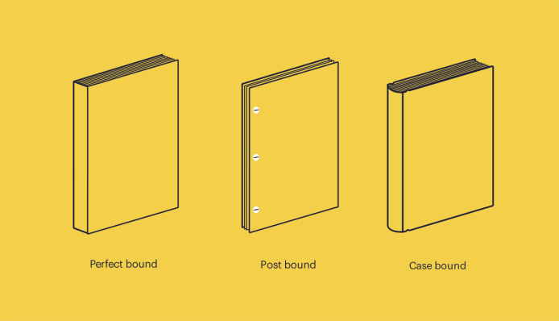
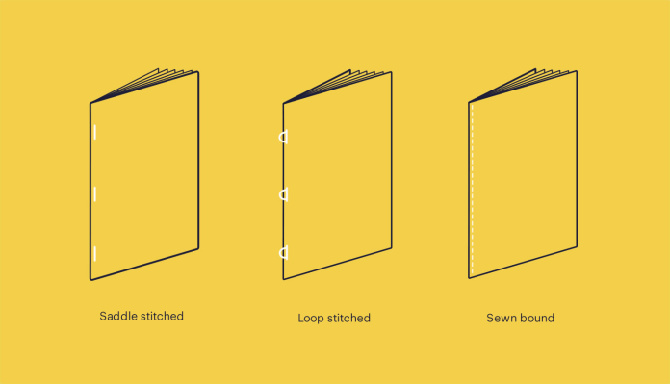
BINDING: The method of holding the leaves of a book together. While the leaves may, in fact, be held together by gluing, sewing, or stapling, the term is used to refer to the outer covers of a book, as if it were the covers holding the leaves together. Thus, books are said to be bound in boards (alone), boards covered with cloth, paper, or various types of leathers, and enclosed in wraps.
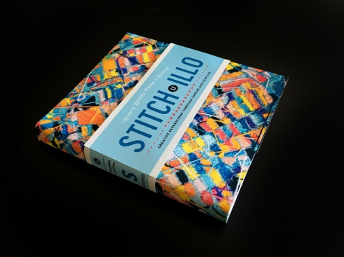
BELLYBAND, OBI, or TUMMY: A type of dust jacket that covers only a portion of a book

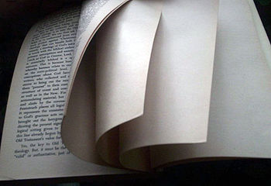
BLANK: A page or leaf of a book which is devoid of printing or anything else. Blanks are intentional, but those found at the end of the book (other than a single flyleaf) are less so, being the result of a book's final Gathering having less than its total pages printed.

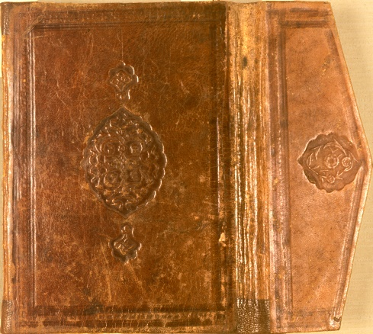
BLINDSTAMPING: Letters, decorations, or other marks which have been impressed (usually) in the binding without further adornment such as gilt or color.

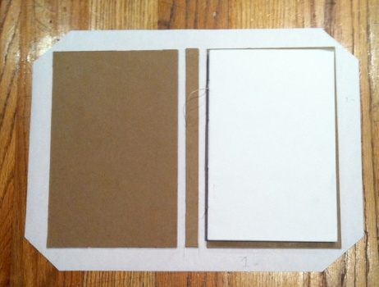
BOARDS: The material used in the covers of modern hardbound books composed of stiff cardboard or a similar material. Where the term alone is used to describe the covers, it means the binding is paper-covered boards. It is usually covered with materials such as cloth, leather, or vinyl.

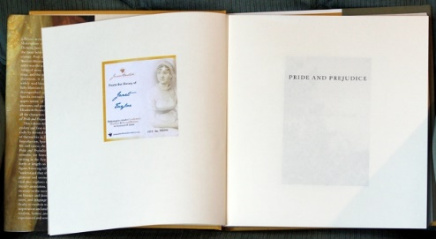
BOOKPLATE: A bookplate, also known as ex-LIBRIS [Latin, "from the books of..."], is usually a small print or decorative label pasted into a book, often on the inside front cover, to indicate its owner. Simple typographical bookplates are termed "book labels".
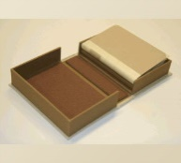
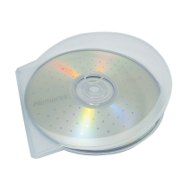
CLAMSHELL CASE or BOX: a type of box for storing paper items in archives (may also refer to either of the two uses above - electronics or packaging)
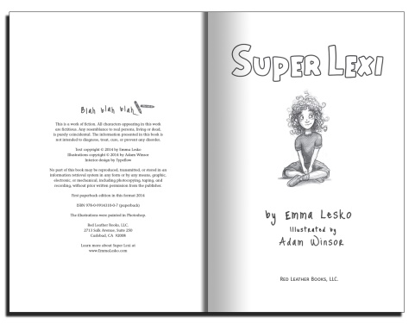
COPYRIGHT PAGE or COLOPHON: Technical information such as edition dates, copyrights, typefaces and translations used, and the name and address of the publisher or printer. It usually appears in modern books opposite the title page, but in some books is placed at the end (see Back matter). Lengthy colophons for books collecting material from multiple copyrighted works may continue onto pages in the back matter if it will not fit on a single page.
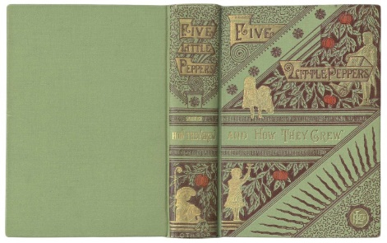
COVERS: Whatever has been used to cover the text block. Typically, it is paper, boards, or boards covered with cloth, leather or paper. The term is often used ambiguously to references the front & back panels of a book, although strictly speaking it should include the spine cover as well.

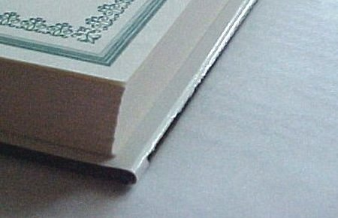
CUT PAGES: The edges of the book's leaves have been trimmed evenly (or flush). Most modern books are so trimmed.

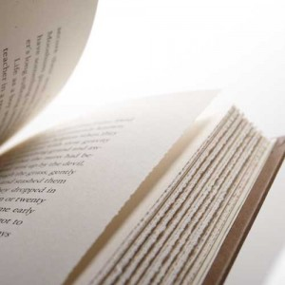
DECKLE EDGES: Another term for Uncut or untrimmed edges.

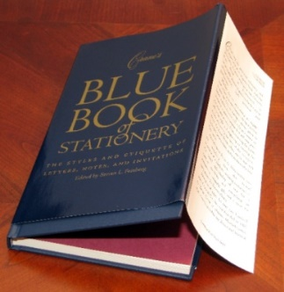
DUSTJACKET/ Wrapper / Dust wrapper / Dustcover / Book Jacket: A protective paper, usually bearing printing & illustrative or decorative designs, which wraps around the covers & spine of a book. The ends of the jacket have flaps which fold under the inside of the covers.

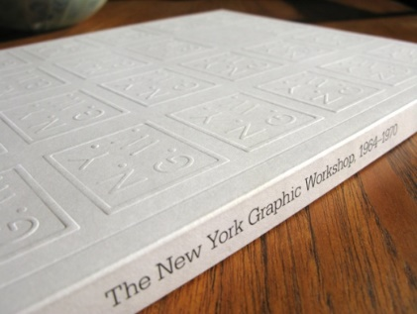
EMBOSSED: The results of a process which produces raised letters or decorations on a surface, i. e. the opposite of the results produced by stamping or impressing.

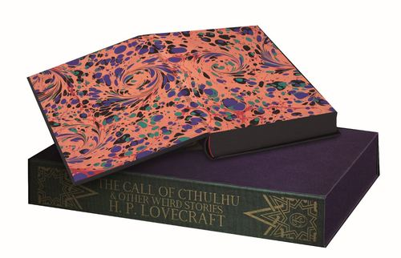
ENDPAPERS: These are first & last leaves found in a hardbound book. Half of each endpaper is pasted onto the inside of one of the covers & the other half joins that cover to the text block. The part of the endpaper which is pasted to a cover is called the Pastedown Endpaper, and the unattached half is called the Loose Endpaper. Because endpapers play a prominent role in the binding of a Case Bound book, they are made from a stronger & heavier paper than Text Paper.

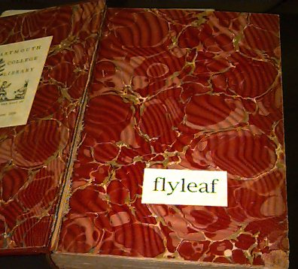
FLYLEAF: The blank leaf or leaves following the front free endpaper, and those (if any) preceding the back free endpaper.

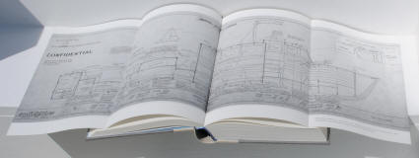
FOLD-OUT: To create a larger space in a smaller book, book publishers use fold-out pages.

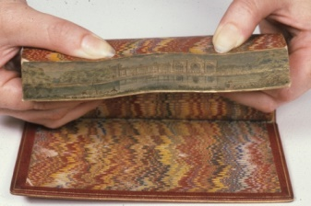
FORE EDGE: The collective edges of all the leaves opposite the spine or bound edge of a book.

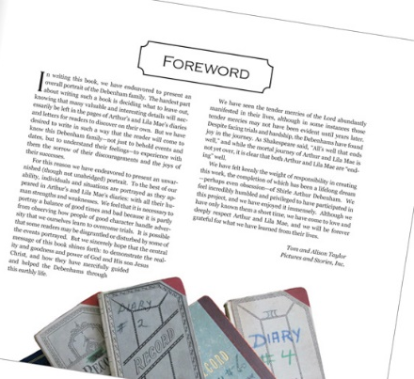
FOREWORD: A foreword is an introductory section of a book written by someone other than the author, usually a prominent figure like an expert on the subject matter, another author, or a critic. A foreword lends credibility to the book and author by praising the work, the writer, or both.

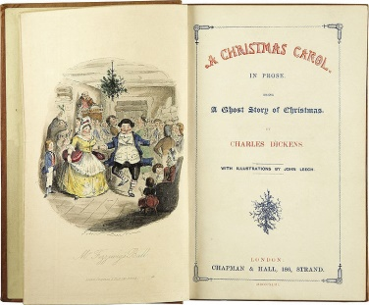
FRONTISPIECE: an illustration facing the title page of a book.

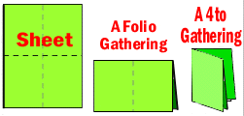
GATHERING: The group of leaves formed when a single printed sheet has been folded into the leaves which will appear in the finished book. A series of these gatherings, arranged in the proper order, are then stitched together to form the text block of the book. The term is also used in the plural to reference the entire series of individual gatherings prior to binding. Once bound each individual gathering is called a Signature.
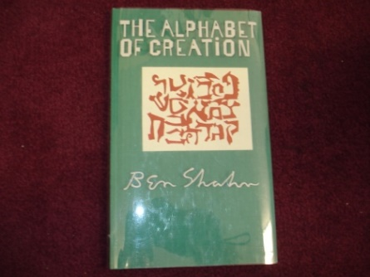
GLASSINE: A translucent, smooth, lightweight, dense paper which has been coated with silicon (or a similar agent that inhibits adhesion to another surface) and intensely calendared (smoothing between rollers). It is greaseproof & and moderately resistant to the passage of moisture & air. Most commonly used for food packaging & holding stamps, occasionally it make an appearance as a dustjacket.

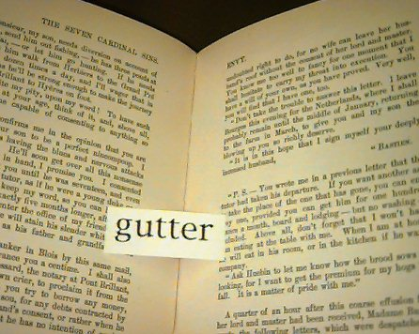
GUTTER: The trough formed by the adjacent inner margins of facing pages in a book.

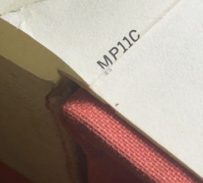
GUTTER CODE: The gutter code was used by Doubleday, both for their trade and book club printings, from mid-1958 to mid-1987. Collectors have deciphered this code as an indicator of when the book was manufactured. The codes are stamped in the gutter of one of the last printed pages in a publication, usually the last page of text. Non-first edition trade printings and book club edition (BCE) printings do not contain explicit statements of edition or printing dates, so the gutter code is the only way to date them reliably if secondary sources such as book club announcement fliers are not available.
The gutter code is usually a letter followed by two digits. The letter indicates the year and the two digits are the week of the year.
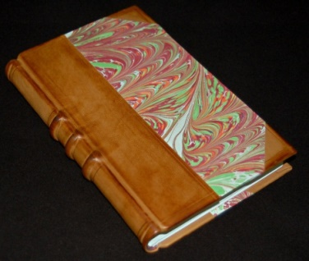
HALF BOUND: A book in which the spine and corners are bound in a different material (usually a better material such as leather) than the remainder of the boards which can be covered with plain paper, marbled paper, or cloth. Although infrequently found, there are half-bindings with fore edge trim in which the spine & the right edge of the cover(s) are trimmed with the center portion covered in cloth or paper.

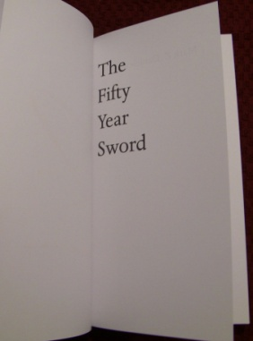
HALF TITLE PAGE: The half title or bastard title is a page carrying nothing but the title of a book—as opposed to the title page, which also lists subtitle, author, publisher and edition. The half title is usually counted as the very first page in a printed book.

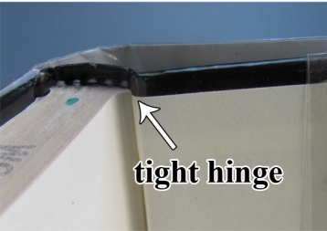
HINGE: The flexible channel where the paste-down endpaper meets the free endpaper is the visually evident location of a hinge in an intact book. The entirety of the hinge, in both hand and machine bound books, is concealed behind the endpapers. Most descriptions of defective hinges implicitly reference more than the channel). The term is often used incorrectly as interchangeable with the term Joint.
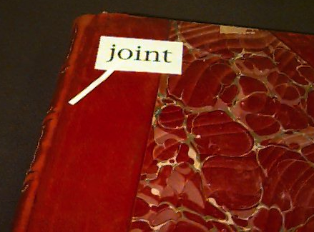

JOINT: the proper name of the flexible groove where the cover Panels of a books meet the spine cover.

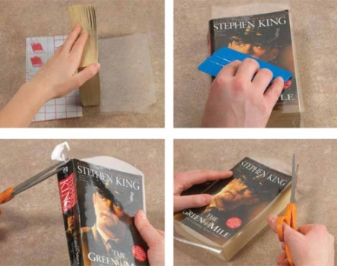
LAMINATION: The application of a transparent plastic film, usually with a high gloss finish, to the surface of paper-based book covers to enhance its appearance & durability. Lamination has often been applied to the covers of modern Paperbacks, and more recently widely used in books bound in both Wraps of all sizes and books in paper-covered boards. Common defects in laminated covers are peeling, lifting & bubbles.

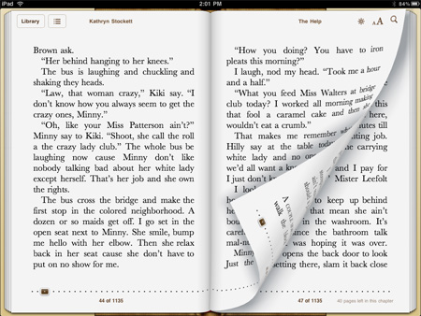
LEAF: The entirety of the single piece of paper both sides of which are a page in a book, i.e. each side of a leaf contains one page. Leaves can be printed or blank.

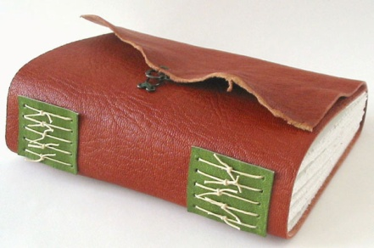
LIMP: A flexible binding which allows the covers of a book to be easily bent. The flexibility of the covers is achieved by the use of naturally limber material and the absence of supporting Boards. The term does not apply to paperbacks or other paper bindings, but is reserved for non-paper binding materials, particularly soft leather or imitations thereof.
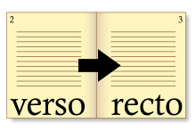
OBVERSE or RECTO: The right-hand page of a leaf in a book.
Page: One side of a Leaf. The front side of a leaf is called the recto or obverse and the back side of the leaf is called the verso or the reverse.

PANEL: Specifically refers to the front or back of a book's cover. Often used instead of the somewhat ambiguous term cover to clarify that reference is being made to only the front and/or back of the cover and does not include the Spine cover. Panel is also used in the same manner to refer only to the front and/or back of a dustjacket.

PASTE-DOWN ENDPAPER: The portion of the endpaper pasted to the inside of a book's cover

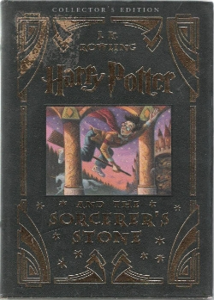
PASTE-DOWN ILLUSTRATION: A paper illustration applied to the front cover of a book bound in cloth or boards. Books bearing such illustrations are also described as having an applied pictorial cover. The illustration, almost always in color, was printed on a fairly heavy paper & then glued to the cover.

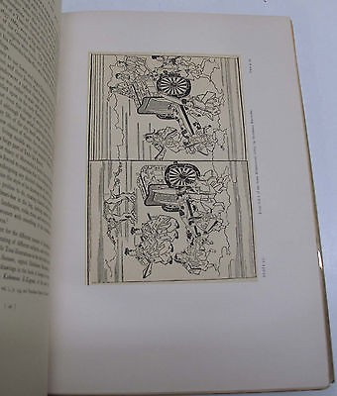
PLATES: A full-page illustration in a book whose reverse side is blank & without text, or contains another full-page illustration. The plates, particularly in older books, are generally printed on paper of a better quality than the text pages and are coated. Many recent books, however, use coated paper for both, and often have more than one photographic illustration on a page each labeled as a plate. It is not uncommon in older books to find plates "Tipped-in, i.e. glued-in after all the Gatherings were sewn together as opposed to being added during the binding process. Many of the plates in older books have a protective thin leaf of tissue-like paper called Tissue Guards placed between a plate's pictorial page & the opposing page. Smaller illustrations printed on the text pages of a book are called Cuts.
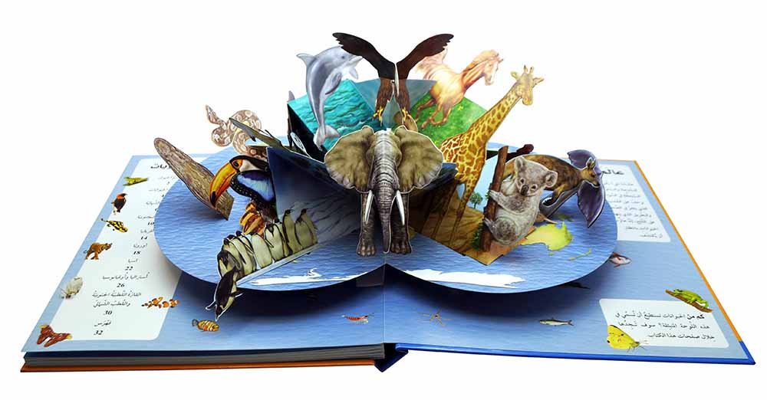

POP-UP elements may be used to add dimensions to the page in different ways. Children's books commonly incorporate a wide array of design features built into the fabric of the book.
PREFACE PAGE: A preface is generally the author recounting the story of how the book came into being, or how the idea for the book was developed. This is often followed by thanks and acknowledgments to people who were helpful to the author during the time of writing.

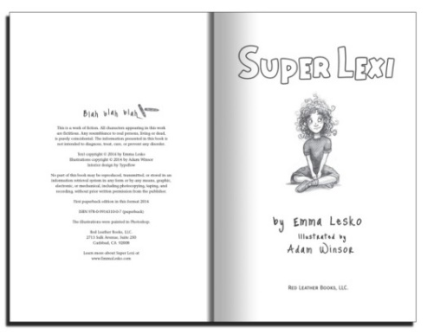
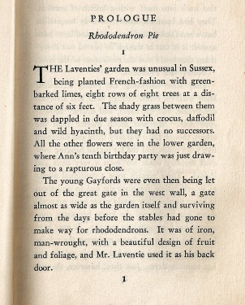
PRELIMINARY PAGES: The printed pages preceding the main text of a book, which may include and are often in the following order: Half-Title, Frontispiece, Title Page, Copyright Page, Dedication, Preface or Forward, Table of Contents, List of Illustrations, Introduction, Acknowledgments, and 2nd Half-title. Particularly in older books, the preliminary pages are numbered with Roman numerals, if numbered at all.

PROLOGUE PAGE: Usually present in fiction or narrative nonfiction, the prologue is an opening to the story that establishes the setting and gives background details, often from some earlier or later timeframe that ties into the main one.

PROMOTIONAL WRAPPER: A dustjacket-like wrapper which wraps around a dustjacket, the book itself, or a slipcase. Such wrappers are generally about half the size of a dustjacket, and are used to promote the book itself (an auto-promotional wrapper), a related motion picture, another book by the same publisher, etc. Promotional wrappers are also found on magazines.

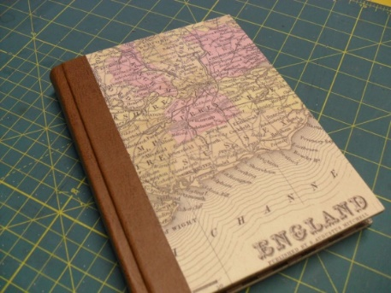
QUARTER BOUND: A book whose spine & a small adjacent area of the Panels are bound in a different material than the reminder of the panels. Generally the spine cover is of a better material than that used on the panels, e.g. leather or cloth where the covers are boards or paper-covered boards.

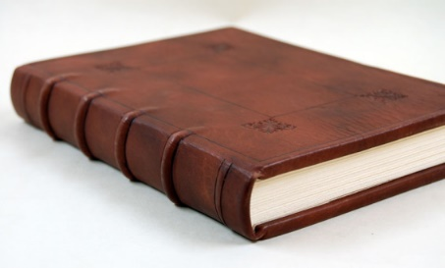
RAISED BAND: A raised, horizontal band across the spine of a book. Prior to early in the 19th century when books were bound by hand, two or more leather bands were stretched across the spine of a book and a cord was tied to each side of each band. These cords were stretched across the front & back boards & tightly tied to the fore edge of each board. The leather binding was then molded around the raised bands concealing the cords. After this "tying up" period ended with the introduction of Case Binding, the appearances of raised band remained popular and are still used today as a purely decorative device.
RECTO/OBVERSE: The right-hand (front) side of a leaf in a bound book.

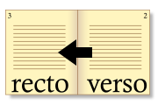
REVERSE/VERSO: The left-hand (back) side of a leaf in a bound book.

SELF-WRAPS/SELF-WRAPPER: A paperback book whose covers imitate a dustjacket (wrapper) by having a flap which folds under the front & back cover.

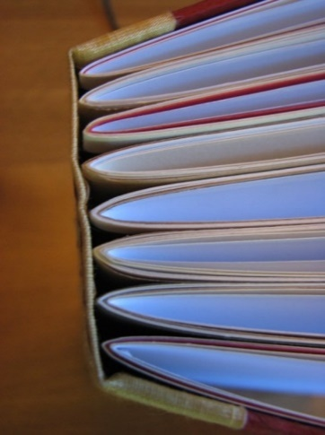
SIGNATURE: A Gathering of leaves which has been bound & trimmed with other gatherings to form the Text block of a book. Also refers to the small identifying marks (usually lower case letters) printed and so placed on the printer's Sheets as to appear at the beginning of each folded gathering, thus aiding the binder to assemble the gatherings in the correct order.

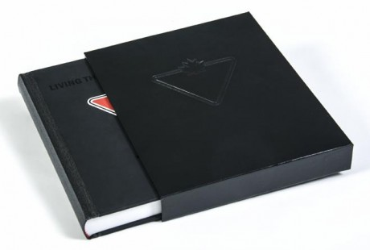

SLIPCASE: A protective box with one open side into which one or a set of volumes is "slipped" with the spine(s) facing outward.

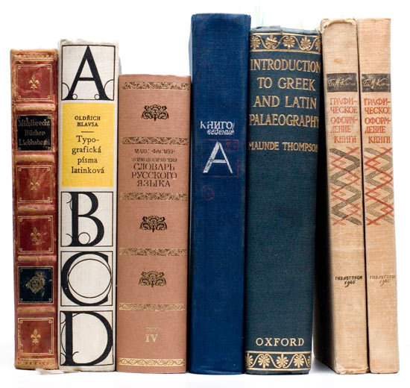
SPINE: The edge of the book opposite the fore edge where the Signatures are sewn & glued together as opposed to the spine cover.
Used ambiguously to refer either to:
(1) The part of a book's cover which wraps over the back of the book (also called the Back strip or Spine Cover); or
(2) The back portions of the attached Signatures which form the rear edge of the Text block (also called the Backbone).

Fortunately, the context in which the term is used rarely causes confusion.

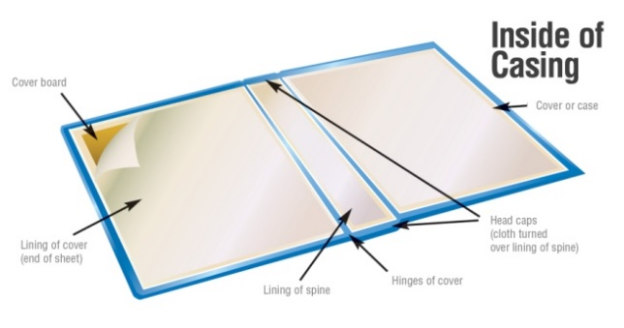
SPINE LINING: In a case bound book, the strip of cloth or cardboard which, along with the hinges, attaches the text block to the case. In case books using this construction (many today do not), the spine lining also functions to reinforce the hinges The cloth is glued to the back of the text block (the spine) and to the inside of both boards. The spine lining is concealed by the spine cover and by the paste-down endpapers.
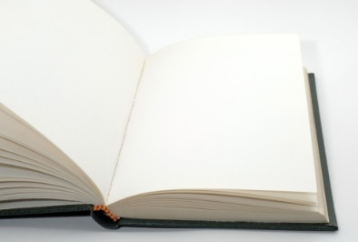
TEXT PAPER: The type of paper upon which the text in a specific book is printed, assuming that the same paper type has been used for all text-printed pages. The term is used when there is a need to distinguish the text paper and the other paper portions of a book such as the plates, endpapers, covers, etc.

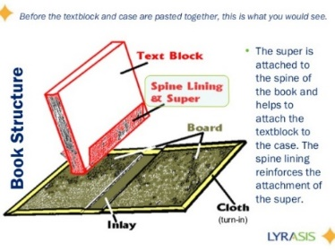
TEXT BLOCK: The part of a book, consisting of all & only the sewn or glued Signatures forming its leaves, which is bound by, but does not include, the Covers or the Endpapers both of which are part of the binding. The text block in a machine-made, hardcover book is what is enclosed in the Binding Case.

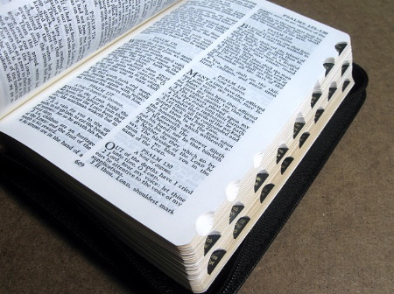
THUMB INDEX also called a cut-in index: A set of lettered or marked grooves cut down the side of a book, especially a diary or dictionary, for easy reference.

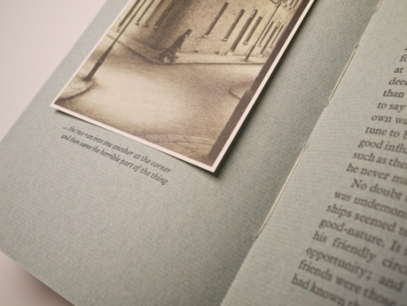
TIPPED IN: Describes material glued into a book which was not part of the printed gatherings and added at a later stage in the book's making, or as a means of reattaching loose or detached material to salvage a book. The candidates for such material in both cases are Leaves, Plates and Errata Slips.

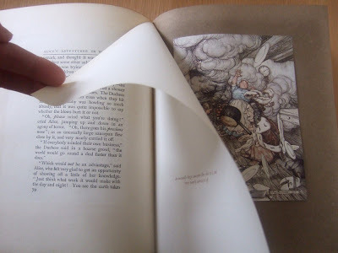
TISSUE GUARD: Commonly in the 19th century, and to a lesser extent thereafter, some publishers placed a protective thin leaf of tissue-like paper between a plate & the opposing page. Some books may have all plates so protected, or only the Frontispiece. Most tissue guards are blank, but occasionally they are found with a printed caption about the plate. A book missing one or more tissues guards is a very minor defect generally ignored by collectors.

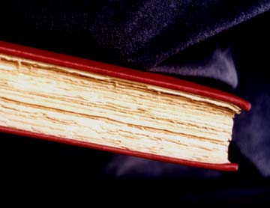
UNCUT: Refers to the untrimmed state of one or more of the edges of a book. Most books have their edges trimmed to produce the appearance of a uniform, smooth surface. An uncut edge has a rough, ragged appearance as do the edges of the leaves comprising the edge
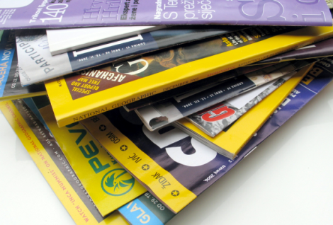
WRAPS or WRAPPERS: The paper covers used to bind a book, pamphlet, magazine or other "soft cover" reading material, but is distinguished from Self-Wrappers because the paper used is distinctly different from the Text Paper. Wraps are made of a heavier weight paper (although always flexible & less than board grade) than the text paper, and may be coated, textured or have various finishes. Although the common paperback books published since the 1930s are bound in wraps, they are usually described as paperbacks or as soft bound. Wrappers should not be confused with Dust wrapper or Wrapper.

