VolunteerMatch and LinkedIn have teamed up to use both of their vast networks to help us recruit high skilled volunteers!  Here’s how it works:

* If you have assigned a “Skill” to one of your VolunteerMatch volunteer opportunities, it is already showing up on  LinkedIn now as well as on VolunteerMatch.
* If you haven’t added your organization’s LinkedIn url to your organizational profile on VolunteerMatch, that volunteer opportunity is showing up under VolunteerMatch’s LinkedIn account.

**So, to make the most of this new service**, you want to add a “Skill” to your VolunteerMatch postings, AND add your organization’s LinkedIn URL to your VolunteerMatch profile.  Here’s how to do both:

**Add a Skill to a Volunteer Opportunity on VolunteerMatch**

When posting or editing a volunteer opportunity on VolunteerMatch, on page 3 you can choose from an array of skills needed for the volunteer position you are recruiting for.  When you click “Select Skill” in the middle of the page, that first list pops up.  If you click on one of those – i.e., I clicked on “Marketing,” additional specific skills are shown.  Pick one or more of the appropriate skills for the position – like Graphic Design or Public Relations -- and add it to your volunteer opportunity to make it show up on LinkedIn as well as on VolunteerMatch.  (NOTE:  You may also type in skills you need that are not on this these lists, however, the skills you type in won’t show up on LinkedIn.  So try to use at least one from the skill list provided.)

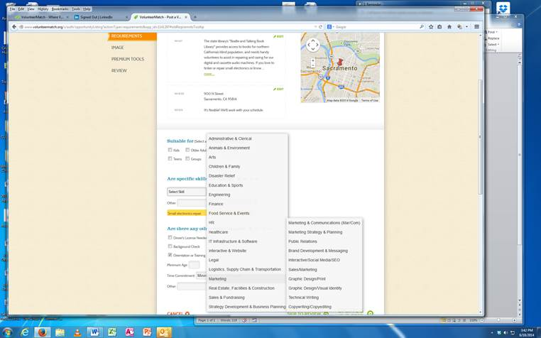

**Add Your LinkedIn URL to Your VolunteerMatch Profile**

On your VolunteerMatch page, click on “Edit Organization Profile” in the lefthand column under “Manage Organization.

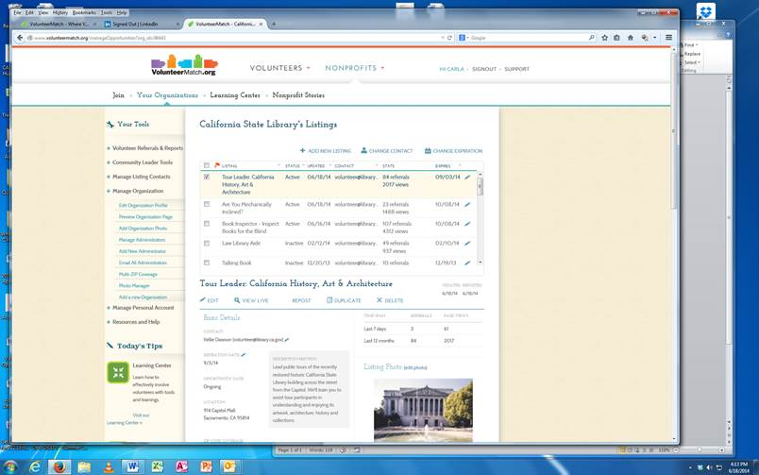

Below is what you’ll see.  Just above where you enter your mission statement, you’ll see “LinkedIn URL” – I have entered the one for the State Library.  You can find yours on the LinkedIn page for your library.

